Session 1: Professional Organizational Behavior

1. What Is Organizational Behavior (OB)?
Definition:
Organizational Behavior is the study of how individuals, groups, and structures affect behavior within organizations, with the goal of improving organizational effectiveness.
Why Do We Study OB?
- To understand ourselves and others at work.
- To work better in teams.
- To function effectively in organizations of any type.
- To prepare for leadership, management, or entrepreneurship roles.

2. Layers of Organizational Behavior
Organizational Behavior operates on three interconnected levels, each with its own challenges.
A. Individual Level
Focus topics:
- Personality
- Perception
- Values & attitudes
- Emotions
- Motivation
- Ethical behavior
- Empowerment
- Job satisfaction
Challenges:
Helping employees stay motivated, satisfied, ethical, and productive.

B. Group Level
Focus topics:
- Communication
- Teamwork
- Power & politics
- Conflict
- Negotiation
Challenges:
Managing diverse teams, improving communication, reducing conflict, enhancing collaboration.

C. Organizational Level
Focus topics:
- Organizational culture
- Leadership
- Decision-making
- Change management
Challenges:
Global competition, managing change, developing effective workforce structures, improving productivity.

3. Traditional ("Old") vs. Modern ("Cool") Companies
“Old” Companies often:
- Have rigid hierarchies
- Follow strict rules
- Hide financial information
- Encourage input but rarely act on it
- Limit flexibility (fixed working hours, high control)

“Cool” Companies:
- Are flexible and informal
- Value employee decision-making
- Offer stock options and childcare support
- Have minimal bureaucracy
- Respect employees’ personal time
- Encourage creativity and open communication
Why This Matters for OB:
The type of company directly affects employee behavior, motivation, and performance.

4. Key Foundations: Organization vs. Structure vs. Design
Organization
A group of people working together to achieve a common purpose.
Organizational Structure
How people and tasks are arranged to achieve goals.
Organizational Design
The process of building a structure that fits the company’s purpose, strategy, and environment.

5. Mechanistic vs. Organic Organizations
Mechanistic (Formal)
- Highly structured
- Specialization
- Clear hierarchy
- Vertical communication
- Lots of rules, policies, and procedures

Organic (Informal)
- Flexible
- Team-oriented
- Horizontal communication
- Adaptive to change
- Fewer rules, more personal coordination

6. Major Types of Organizational Structures

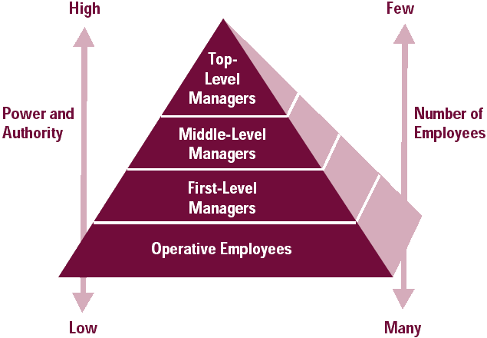
1. Bureaucratic Structure (Mechanistic)
- Strong hierarchy
- Clear job specialization
- Formal rules and procedures
- Vertical communication
Best for: Large, stable organizations.

___________________________________________________________________________
2. Departmentalization (Functional Structure)
Employees are grouped based on expertise:
Marketing – HR – Finance – Operations – IT
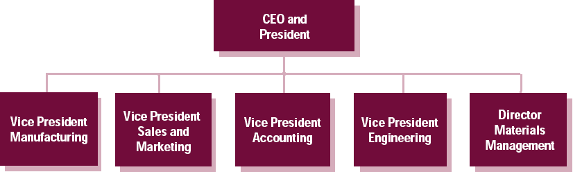
Advantages:
- Efficiency
- Specialization
- Clear career paths
___________________________________________________________________________

3. Hybrid / Mixed Structure
Combines multiple structures for flexibility.
Example: A company may have functional departments + product teams.
Advantage:
Balances specialization and flexibility.
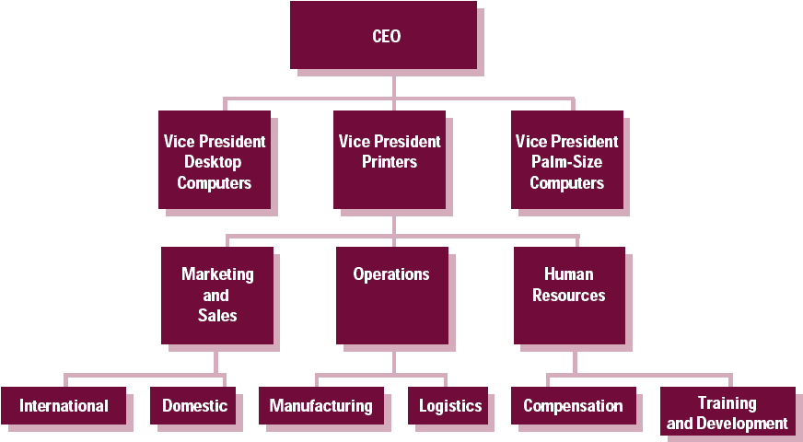

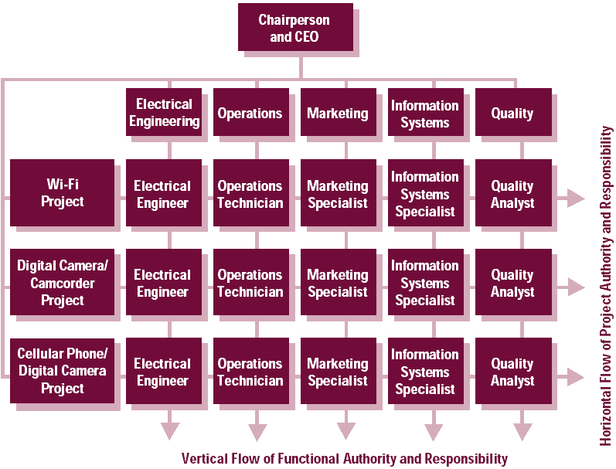
4. Process-Based / Matrix Structure
Employees report to two managers (functional + project).
Used for:
- Product launches
- Client-based work
- Continuous projects
Advantage:
Fast response to new opportunities.

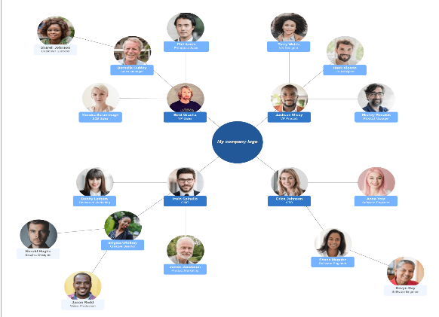
5. Circular Structure
Leaders are at the center, not the top.
Information flows outward.
Advantage:
Enhances communication and collaboration across departments.

6. Horizontal / Flat Structure
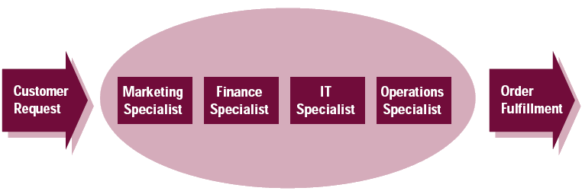
- Few or no hierarchical levels
- Employees work in teams
- High autonomy
- Focus on customer needs
Advantage:
Fast decision-making, strong teamwork culture.

7. Real-World Examples
- Mechanistic: Government agencies, military, large traditional corporations.
- Organic: Tech startups, creative agencies, modern tech companies (e.g., Google, Spotify).
- Matrix: Many consulting firms, aerospace companies (e.g., Boeing).
- Horizontal: Some customer-driven companies (e.g., Zappos).

___________________________________________________________________________
8. Key Takeaways
- OB helps us understand how people behave at work.
- Companies differ greatly depending on structure and culture.
- Structure influences communication, decision-making, flexibility, and employee motivation.
- Modern companies tend to value autonomy, teamwork, and open communication.
- Understanding OB makes you a better team member and future manager or entrepreneur.

